CLARKE MANCINI
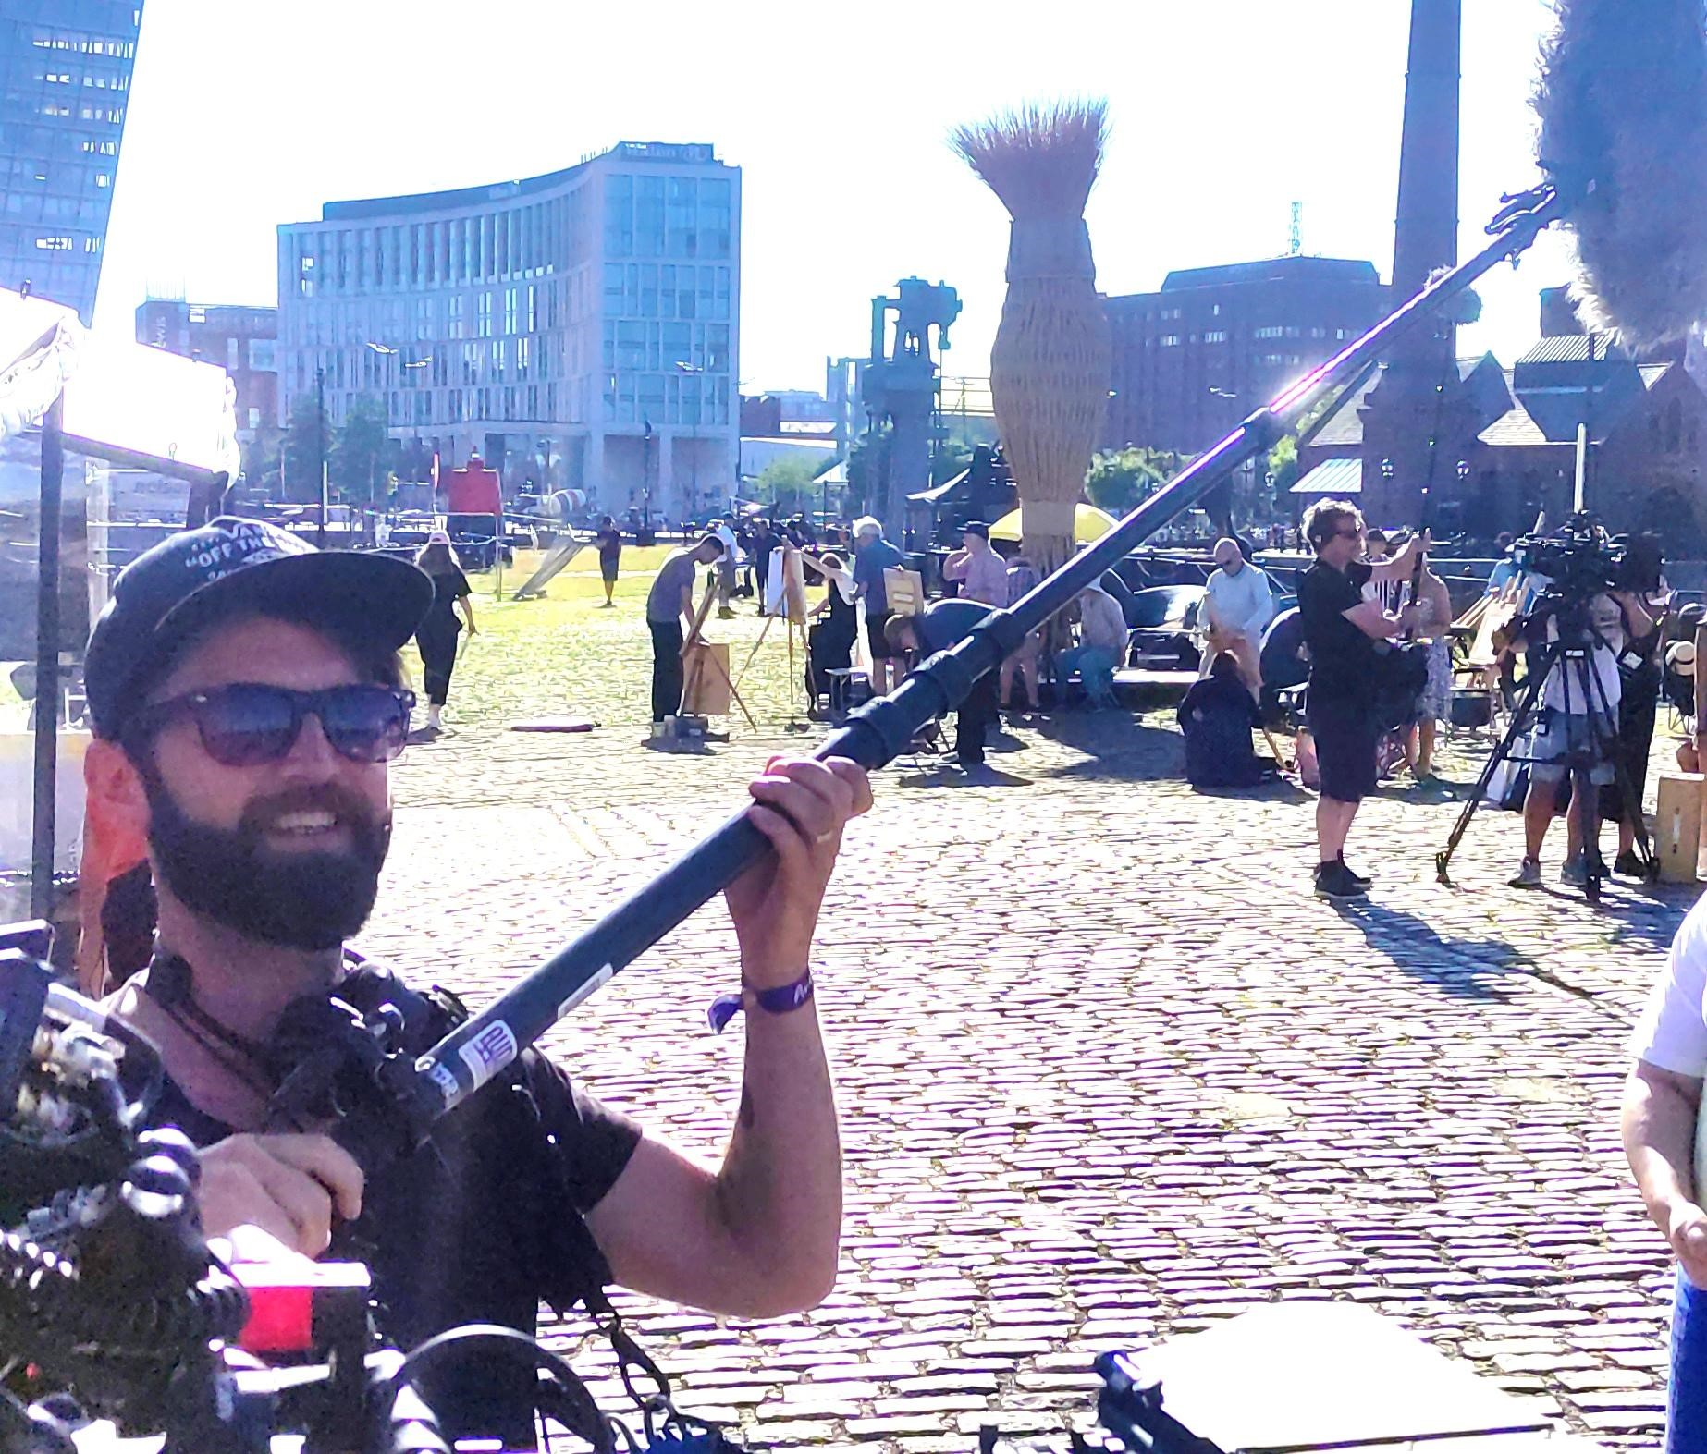
CURRICULUM VITAE
FREELANCE SOUND MIXER & RECORDIST
Email: clarke.mancini@gmail.com
Mobile: +44 (0) 7886 670926
Address: Pen Hill Cottage, West Witton, N.Yorks, DL8 4LX
D.O.B: 02/02/1984
PROFILE
- Over 20 years of experience working in TV production.
- Eight years employment as a Supervisor for Sky TV, Supervising and Guaranteeing all kinds of sports shows such as Premier League Football, PGA Golf, International Cricket and NFL which are all broadcast in 5.1.
- I was the Supervisor on Soccer AM mixing a full audience magazine show with weekly full live bands.
- Eight years as a freelance Sound Mixer and Recordist. This included bringing full studio specs to location productions, providing talk back, timecode, monitoring and full digital recordings. In 2013 I provided recordings for; Portrait Artist of the year, Landscape Artist of the year, Great British Sewing Bee, Echovelvet Productions and adverts such as Sky Bet, Sure and Kia.
- While at Sky I was also a studio guarantee, setting up comms for broadcast programming Riedel and BNCS comms systems.
- During the sports seasons I mix and Assist at Stadiums for companies such as EMG, Timeline and NEP.
- A professional touring Drummer with many years’ experience being in, and working with bands, PA’s front of house and more.
SHOW REEL
- Landscape Artist of the Year
- Portrait Artist of the Year
- Great British Sewing Bee
- Soccer AM
- EMG
- Timeline
- Sky Bet Advert
- Chelsea TV
- NEP Premier League Football
- Sky Golf
- Sky Saturday Social
- Sky NFL
- Spiderverse Movie Shoot
- This Morning
- Loose Women
- Monday Night Football
- Goals on Sunday
- Sky Racing
- Sky News
- Sky Sports News
- House of Dragons
- Sky Movies
TECHNICAL EQUIPMENT FOR HIRE
- Sound Devices 633 Mixer ● 2 x Sennheiser G3 mic with cos 11s ● 2 x cams Ultrasync time code. ● 1 x Sony mono camera link
- 1x Sennheiser 416 Boom mic

TECHNICAL EXPERTISE

- CALREC – Apollo, Artemis, Alpha, Brio, Omega.
- YAMAHA – QL1, LS9, DM1000.
- RIEDEL
- WIZZICOM
- RTS
- SOUND DEVICES – 6 Series, 8 Series, Scorpio.
- ULTRA SYNC
- ZAXCOM
EDUCATION
Hill Community School (1995 – 2000)
12 GCSE’s A– C
Queen Mary’s College (2000 – 2002) B – TEC National Diploma in Popular Music
REFERENCES
Alex Judd Sound Team Leader
Sky Studios
Grant Way
Isleworth
TW75QD
Alex.judd@sky.uk

Richard
Meredith | Audio Dept  Isleworth  London  02032750040

